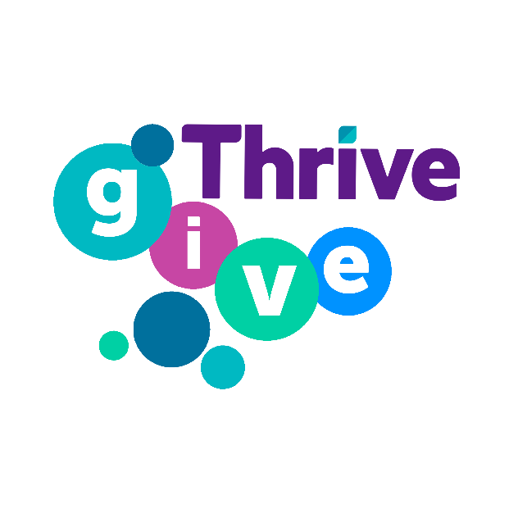

Community Grant

Application Form
Grants over £500

Welcome to GIVE Grants

Thrive Homes is keen to support projects that are making a real difference to our residents and the wider community.

Our community grants back local schemes and organisations that have the resources, experience or ideas that help make a positive difference and uphold our values.

We want to fund projects that reflect the five themes below and can demonstrate a direct impact on:
- Training, employment and enterprise
- Social inclusion
- Health and wellbeing
- Financial inclusion and support
- Environmental sustainability

When completing the form please read each question carefully and provide the relevant information where required. You may also provide additional information sheets if necessary. The electronic format of this application form can be found on our website www.thrivehomes.org.uk/give-grants

The Marketing Communications Team at Thrive Homes is available for impartial guidance in filling in this application form, for further help please contact:

Fiona Frost
Tel: 0800 917 6077
Email: communications@thrivehomes.org.uk

Project Name

Your Details
Organisation name:
Are you a registered charity? | Y/N
If yes please provide your registered charity number
Contact name:
Email:
Phone:
Address:

About Your Organisation
Provide a brief description of your organisation or activity.
Please note this may be used in marketing material
Max 200 words

Project Aims
What are you aiming to achieve with the grant?

Please give an outline of the project, including any evidence of support from partner organisations i.e. the local authority and the local community.

Max 250 words
Who and how many Thrive residents would be engaged in or benefit from the project?

Please highlight if your project aims to work with any disadvantage groups or ‘hard to reach’ sections of the community.

We want to fund projects that reflect the four themes below and can demonstrate a direct impact on:
- Training, employment and enterprise
- Social inclusion
- Health and wellbeing
- Financial inclusion and support
- Environmental sustainability

Max 250 words
Please select the theme(s) which best match your project. | ☐Training employment and enterprise
 | ☐Social inclusion
 | ☐Health & wellbeing
 | ☐Financial inclusion and support
 | ☐Environmental sustainability

How do you propose to measure, monitor and manage your project timetable and spending?

Explain the results you expect from your project. A successful applicant should demonstrate direct links between what the project is aiming to do; what the project involves; what measurable results there are from the project; and what the implications of the project and its results are for the anticipated beneficiaries.
Note that all projects will be expected to submit regular progress monitoring, and you will be expected to provide reports to Thrive Homes regarding progress and achievements, either monthly or quarterly.

Max 250 words

Project Costs
A successful project bid should demonstrate a detailed breakdown of your proposed costs against the anticipated budget. This should include things like costs associated with staffing, activities, overheads, contracts and other specified costs.
Thrive Homes will encourage projects that can unlock other sources of funding e.g. match funding, mainstream funds. It is expected that project applications make explicit any other sources of funding and acknowledge any risks involved (in Section 5).
What is the total cost of your project? | £
How much grant funding are you applying for? | £
How are you hoping to receive the rest of the financing?
If you are planning to continue the project in the future, how are you going to finance it?

Managing Risks
What are the key risks involved in this project?

We expect all projects that apply via our small grant application to meet the necessary legal requirements needed to run your project or event. Please confirm you have the necessary requirements in place – if you are unsure, please contact us.

Max 250 words

Legacy
What is the project’s legacy expected to be?
Once completed, a successful project bid should be able to demonstrate any relationships to what happens next e.g. what the exit strategy will be; how it affects lasting improvements; if and how the project is to continue; how it impacts on other work; or engages other funding streams.
Thrive Homes is keen to fund projects that are sustainable and can demonstrate lasting benefits to residents and the local community.

Max 250 words

Signature:
Printed name
Date:

Media & Marketing
Are you happy for us to use details of your organisation in marketing materials promoting our partnership? | Y/N
Media Contact (if different from above)
Email
Phone
Please tell us where you heard about this community grant opportunity.

We, Thrive Homes, acknowledge that your personal and/or organisational data is being collected on this form. For more information, please refer to our privacy notice at www.thrivehomes.org.uk/privacy-notice

Next steps
Our application process runs in April-May each year. Please refer to our website for further details and specific deadlines www.thrivehomes.org.uk/give-grants
All completed applications should be returned by email to communications@thrivehomes.org.uk
If you have any questions or comments please call the Marketing Communications Team on 0800 917 6077

